Contents

Main capabilities 1

**Build Guide** 1

**User Guide for MIT Gen 1 Chamber** 9

**Maintenance and Troubleshoot Guide** 13

**Bill of Materials** 14

**Extra Data** 18

**MIT Gen 2 Chamber Build Guide, User Guide, Bill of Materials**

Main capabilities

* Humidity Range: 15 to 80 ± 3 % (with nitrogen gas inflow)
* Temperature Range: from room temperature to approx. 100 ± 2 °C
* Illumination Range: 0.1 to 1.1 Sun (with UV, class AAA without the degradation chambers - the transparent degradation chambers filter out especially UV light)
* Samples: Up to 28 1 inch by 0.5 inch samples on the sample holder
* Measurement Frequency: Limited by storage only

# **Build Guide**

Note: This build guide is to be used in conjunction with the MIT Gen 2 Chamber CAD Design. These steps will reference the 3D design. Please use a CAD software that can visualize .STEP files so that you can follow along with the instructions.

See Bill of Materials for the detailed list of components. Before reading this guide, read the guide for the MIT Gen. 1 chamber (<https://github.com/PV-Lab/hte_degradation_chamber>). This guide describes only the steps that are different from MIT Gen. 1 build.

**Chambers**

1. Assemble the two nested chambers (Figure I) from transparent low-iron, high-transmissivity crystal glass tanks. These tanks were purchased off-the-shelf due to the high-fidelity, water-proof seals at each edge. The glass pieces are cut to a 45° degree angle for a better bond, which is hard to achieve without precision tooling. The glass pieces are adhered using a thermal bonding adhesive.
   1. There are the inner and the outer chambers. The inner chamber is nested within the outer chamber. The inner chamber is inverted and retained against buoyancy by a frame affixed to the outer chamber below water level, such that water completely submerges the inner chamber.
2. Cover the outer chamber with insulation pads (cut to the size of the outer chamber) and attach with tape.
3. Cut the alignment pads (for aligning the inner chamber within the outer chamber) according to the measurements shown in the CAD file. Attach the alignment pads to the chambers with glue.
4. Attach the string handle to the inner chamber with glue so that it will not cast shadow onto the samples.
5. Check that the black-out curtains can be folded so that they cover the chamber completely. The curtains are required in addition to the insulation pads because the insulation pads do not fully block illumination from the outside.

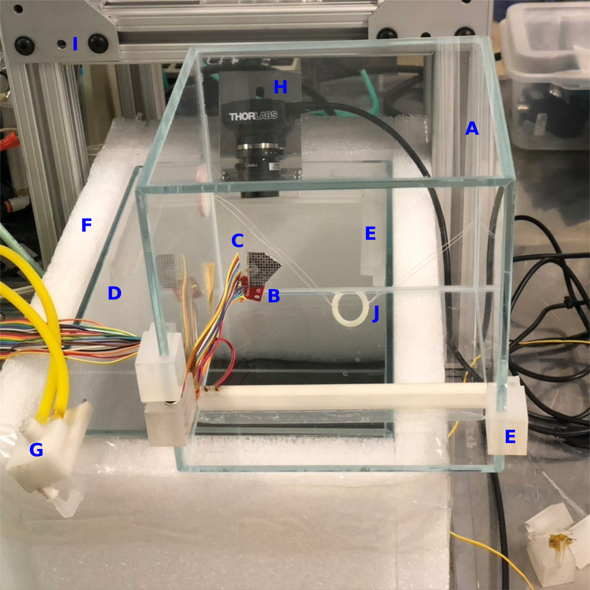

Figure I: The degradation chamber consists of two small, nested chambers. The inner chamber (A, shown here on its side for clarity) accommodates the humidity-temperature sensor (B), light intensity sensor (C), and the sample holder (not shown). The inner chamber slids accurately into the fixed positions within the outer chamber (D) with the aid of plastic alignment tabs (E). The outer chamber is covered with insulation pads (F) to minimize heat loss and to prevent reflections from outside. The air humidity is controlled with a dry gas line (G). The degradation of the samples is followed with a camera (H) that is attached to the outside of the outer chamber. The solar simulator (not shown) rests on top of an aluminum frame (I). The closed outer chamber is slid below the frame to run the chamber. The inner chamber can be moved by the string handle (J)

**Support Frame**

1. Assemble the frame according to the measurements in the CAD file. All the seals need to be completely water-proof.
2. Check that the outer chamber fits securely into its place, this will ensure that the illumination intensity conditions remain the same even though the chamber would be removed and put back during the aging test.

**Solar simulator**

1. Assemble and connect the Sunbrick solar simulator according to the instructions from the manufacturer.
2. Attach the solar simulator on top of the Al frame.

**Camera setup**

1. Attach the lens to the camera and connect the camera to the control laptop (see MIT Gen. 1 guide).
2. Bend a support plate for the camera according to the CAD file. Drill holes to the plate and to the ceiling of the outer degradation chamber for attaching the camera.
3. Attach a circular quartz plate to the ceiling of the outer degradation chamber so that it fills the field of sight of the camera (Figure II). The quartz plate is required for removing reflections and glare from the pictures.
4. Attach the camera to the outer chamber and adjust it (see MIT Gen. 1 guide).

Figure II: The camera is attached to the outer chamber to look through the quartz plate.

**Color calibration and light intensity tracking setup**

1. Wire and connect a Si solar cell into the inner chamber securely so that it does not shadow the samples.
2. Check that XRite color chart can be placed into the picture area (see MIT Gen. 1 guide).

**Humidity control setup**

1. Prepare a dry gas (either nitrogen or dry air) line for the aging chamber. Use increased ventilation in the room. Use also fume hood if the samples are expected to release toxic substances in gas form.
2. Connect the magnetic valve to the dry gas line. Connect the valve to Arduino via the circuit shown in Figure III. Use long enough wiring for moving the chambers in and out their measurement position.Shape

   Description automatically generated with medium confidence

Figure III: Circuit for the humidity control system.

1. Prepare a press-fit head (Figure I, part G) for the dry air line from plastic according to the measurements shown in the CAD file. Press and click the dry air line to its place in the bottom edge of the inner chamber (Figure IV).
2. Attach Si7021 sensor into the inner chamber so that it does not cast shadow onto the samples (see MIT Gen. 2 guide).
3. Half-fill the outer chamber with water. Then nest the inner chamber within the water environment, pressing the inner chamber into the rails affixed to the outer chamber, such that the inner chamber resists the upward buoyancy force. Fill the outer chamber with water until the water level rises above the top of the inner tank, roughly ¼’’ above the inner tank ceiling to ensure that the 1/16’’ acrylic sheet is wetted to minimize diffraction seen by the camera above the water.
4. The water is circulated with a Masterflex peristaltic pump with an easy-load rolling chamber for Masterflex L/S 14 silicone tubing (or any 5/8’’ OD with 1/16” wall thickness flexible tubing will get the correct water flow rate). The water is drawn from below the inner chamber and then returned to the jacket water within the outer chamber. The circulation path goes from beneath the sample chamber through a custom inline water heater, described in the following section.
5. A fan ensuring sufficient air circulation is integrated into the sample holder (see the following section).

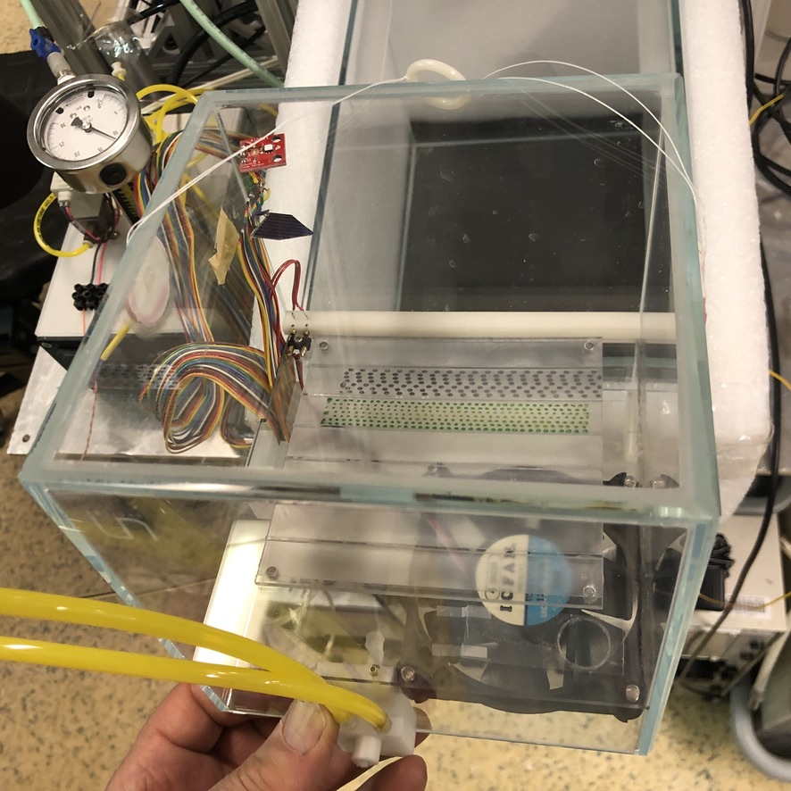

Figure IV: Attaching the dry gas line to the bottom edge of the inner chamber.

**Temperature control setup**

1. The water temperature controls the inner chamber temperature. The temperature is changed by circulating the water through a custom-built electric-resistance heater (Figure V) and then re-introduced back into the outer chamber water jacket.
2. The custom-built electric-resistance heater consists of a 25W resistance element wrapped around a aluminum tube in which the water flows from the inlet to the outlet. The temperature of the water is controlled by the Solo AutomationDirect programmable controller, which receives temperature feedback from a Type-K thermocouple submerged within the outer chamber water jacket.
3. A fail-safe Klixon thermal switch is installed to the exterior of the resistance element casing to turn off the temperature controller if temperatures over 90°C are measured.

Figure V: Custom electric-resistance heater for water temperature control. The water from the outer chamber flows through the inlet tube (A), the inlet and outlet tube are approximately 5/8” OD with 1/16” wall thickness. The water enters the aluminum tube wrapped with a resistance heater enclosed in a metal casing (B). The water exits the heated tube through the outlet tube (C). A fail-safe thermal switch (D) is in place to power off the heater in the event that it exceeds 90C. An 80/20 railing (E) is used as structural support for the device.

**Humidity and temperature tracking setup**

1. An Adafruit Si7021 RH sensor is installed within the inner chamber to track temperature and relative humidity of the sample environment. The accuracy of this sensor degrades over prolonged exposure to high-RH environments, hence, must tracked with care and replaced to maintain reliable humidity level control. An EasyLog USB tracker can fit into the inner chamber to replace or act as a redundant layer of humidity and temperature tracking. The EasyLog USB tracker’s performance degrades much slower than the Adafruit Si7021.

**Sample Holder**

1. Mill the sample holder from a block of graphite according to the measurements in the CAD file (see also Figure VI). The samples shelves are milled at 16 degree angles, such that the samples appear normal to the camera. Drill the screw holes to each corner. Paint sample holder with grey matte paint that survives ultraviolet light, high temperature, and humidity. You may also add sample holder heating as described in MIT Gen. 1 guide.
2. Cut the plastic base plate for the sample holder according to the measurements in the CAD file. Drill a circular 16 mm hole to the corner of the base plate to facilitate air flow from the fan. A ventilation flap covers the hole to inhibit water vapor from entering the internal chamber when the fan is turned off. The flap can be constructed using a thin polymer sheet, taped on one end to the plastic base plate and free at the other end to open when fan turns on and seals when the fan turns off. Drill to the base plate also a hole for the wiring of the computer fan. Attach the sample holder to the base plate.
3. Attach an 80mm computer fan to the underside of the base plate (air flow from down to top).
4. Prepare the alignment plates for the sample holder and glue them into the chamber.
5. Place the sample holder into the inner chamber. Use camera live feed to adjust the sample holder location if necessary, and perform testing of the setup with water filled into the outer chamber (see MIT Gen. 1 guide).

Figure VI: Sample holder and its base plate. Here, the sample holder is loaded with two substrates of droplet samples.

**Control**

1. Configure the OS and data structure (see MIT Gen. 1 guide for instructions).
2. Install and test all the software and codes required in the use of the aging chamber. For MIT Gen 2 chamber, the codes are provided in two repositories: <https://github.com/PV-Lab/hte_degradation_chamber>_gen2 and <https://github.com/PV-Lab/RGBanalysis> (5/26/2022).

**Test and calibration of the aging chamber**

1. Ensure that the system is not leaking water even in extended use and after repeated handling the chambers.
2. Perform full test and calibration of the chamber (MIT Gen. 1 Guide).

**Software**

1. Download and installation instructions for the control codes of the chamber available in Github repository: <https://github.com/PV-Lab/hte_degradation_chamber>_gen2 (6/6/2022).
2. Download, installation, and use instructions for the result analysis available in Github repository RGBanalysis: https://github.com/PV-Lab/RGBanalysis (5/22/2022).

# **User Guide for MIT Gen 1 Chamber**

* Notes regarding the aging test are to be made in the “metafile_aging_checklist” file. Rename a copy of this file according to the name of your aging test and fill in the blanks.
* Initial preparations
  + Activate/connect the USB port for the humidity tracker. Open the EasyLog Humidity Tracker App on the computer (Figure VII).
    - Stop the humidity meter, collect the data and save it on the laptop.
    - Restart the humidity meter.
    - Deactivate/disconnect the USB port, and check that the green LED of the humidity meter blinks in every 1 min.

Figure VII: View of the control program for the humidity tracker.

* + Check that the USB port for Arduino is active. Open the Arduino program for humidity control.
    - Navigate to Arduino/Tools/System monitor. The program starts printing out current sensor values.
    - Check that the humidity control system reads a valid number (humidity <100%).
    - Set “Desired_Humidity” level.
      * Account for error in the reading of the humidity tracker (Explanation: If the Humidity tracker reads 58%, the humidity controller reads 61%, then the error in the humidity controller is approximately +3%. If you want to set the chamber humidity to 50%, you must enter – 53%).
      * Once ready, press “Verify” and “Upload” in the upper left corner (Figure VIII).

Figure VIII: Humidity control program runs the Arduino.

* + Turn the solar simulator on according to the instructions from the manufacturer. Let the lamps heat up and stabilize for 10 minutes before proceeding with the camera.
  + Fill in the water into the outer chamber.
  + Open the LabView camera control program.
    - Press white arrow in the upper left corner to run the VI (Figure IX).
    - Feed in camera settings (Figure IX).
      * Reference values that typically work: pixel clock 24 / frame rate 15 /exposure time 7.35 ms.
      * Optimal settings for the camera will vary by time, depending on the sample color and lamp aging. Use the same settings during the whole project. You will need to perform a calibration procedure to determine these values. See “Build Guide” – “Test and calibration of the aging chamber” for further instructions.
    - Scroll to the right of the front panel (Figure IX). Enter the path to the data folder (cloud or server folder). Enter frequency of capturing images.
    - Scroll to the left of the front panel (Figure IX). Press “Start Live”
    - Check that the data is saved into your folder.

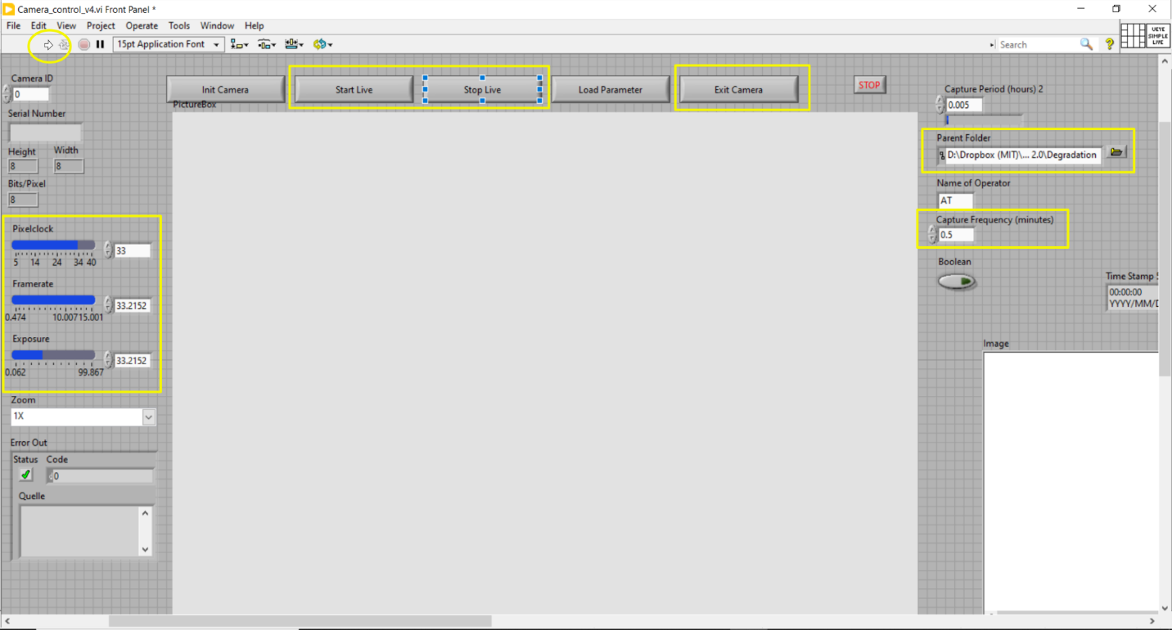

Figure IX: Camera control program. View of the front panel.

* + Take a photo with Xrite reference color chart as the first photo of the aging test.
    - Remove the sample holder from the picture area but leave the insulating pad there. Place the Xrite color chart to the picture area on top of the pad so that its lower right corner (i.e., the corner with white color patch) is aligned with the green tapes marking the sample area and it is aligned straight in the live stream of the camera program.
    - Wait until one picture of the chart has been captured by the camera control program.
    - Open the color chart picture with GNU Image Manipulation Program (GIMP). Navigate to Colors -> Map -> Color Exchange option and check that the white color patch is not oversaturated (i.e., RGB 2must remain below for most of the white pixels 256/256/256). This is just to check the camera settings; you should not save the changes to picture.
    - Remove Xrite color chart and place the sample holder back to its place.
* Putting the samples in
  + Insert all the samples in and log the sample order in the metadata file. Ensure that you are wearing gloves and place the samples on the holder very carefully using tweezers. Avoid dropping the samples or getting scratches on them as this could impact the degradation process. Connect the sample holder fan to its extended wiring while sliding the sample holder into the inner chamber.
  + Place the inner chamber into the outer chamber.
  + Close the lid and put the curtain around the apparatus chambers (do not block the ventilation of the solar simulator!).
  + If there are multiple pictures of the Xrite color chart or pictures of the partially filled sample holder, delete them at this point since the picture analysis program assumes that the first picture of the aging test is of Xrite chart, and the rest are of the filled sample holder.
* Winding Up
  + Log the temperature reading, humidity reading and sample holder temperature into the metadata file. Do the same after 10 minutes and after an hour (optional).
  + Follow the short circuit current of the Si solar cell frequently, and at least at the beginning and end of each aging test. Changes indicate that the intensity of the lamp has varied during the aging test, which may affect the degradation of the samples and will affect the quality of the collected picture data.
  + Check that images are being loaded into the Dropbox folder and that everything is running fine.
  + When you are ready to end the test, note the duration of the test, temperature and humidity readings into the metadata file.
* Shutting Down
  + Turn off the parts of the chamber in reversed order compared to Initial preparations.
    - Camera control program: Press “Stop Live”, “Exit Camera”, and turn off the program.
    - Deactivate/disconnect USB port, turn off Arduino IDE, and turn off fan power supplies.
    - Humidity tracker: Activate/connect the USB port, load and save the tracker data via EasyLog Humidity Tracker App with the name of your aging test, deactivate the USB port.
  + Don’t breathe in the fumes if you smell anything while opening the chambers.
  + Remove the samples.

# **Maintenance and Troubleshoot Guide**

* Maintenance
  + Replacing Si7021 sensor
    - Must be done approximately every 1 month or when the humidity reading begins to deviate from the reference value (EL-USB-2).
  + Replacing XRite ColorChecker Passport
    - Must be done when the colors fade, manufacturer recommends every 18-24 months.
* Troubleshoot
  + Variations in the color data
    - Is the illumination intensity sufficiently even in the picture area?
      * Place a sheet of paper with the color of samples in the picture area to determine the level of spatial variations by taking a picture.
      * Check the alignment of the camera and lamp, and possible reflections from nearby objects, adjust the positions accordingly and attach the components securely.
      * Check that all the LEDs in the lamp turn on, change the lamp if necessary.
    - Is the sample holder heating the samples evenly?
      * Use IR video camera to determine the spatial variations
      * Are the thermocouple and resistive heater properly attached to the sample holder?
    - Are the blackout curtains covering the whole chamber? Outside illumination may distort the data.
    - Make sure of using manually fixed settings of the camera if you are using another camera control program than what is provided here – camera settings may drift over time if they are set to automatic mode.
  + Humidity control programs shows NaN humidity
    - Si7021 connections might have gone loose. Check the connections.
    - The setup is sensitive to voltage peaks – has there been electricity cutoffs recently? If yes, it may be necessary to change the sensor.
  + Humidity control program is irresposive
    - USB connection to Arduino might have gone loose. Check the connections.
    - Arduino may have been busy when you tried to upload the updated code. Power off everything, restart, and try again.
    - The microprocessor is sensitive to voltage peaks – has there been electricity cutoffs recently? If yes, it may be necessary to change the Arduino.

# **Bill of Materials**

* Chamber
  + Clear polished acrylic 5-sided box (outer chamber)
    - Dimensions (W x L x H, cm): 30 x 20 x 20
  + Clear polished acrylic 5-sided box (inner chamber)
    - Dimensions (W x L x H, cm): 16 x 16 x 16
    - Design rules: All edges for both acrylic boxes must be waterproofed. The inner acrylic box must be small enough to be fully inset into the larger box. Box thickness is 0.5cm.
  + Inner chamber base plate
    - Dimensions: see CAD drawing
    - Machined out of approximately 0.5cm thick plastic.
    - Design rules: Drill a 1.5cm diameter hole in the plastic above the fan to allow airflow into inner chamber. A thin plastic flap should be taped on only one side to cover the hole, such that when the fan is on, the flap is free to open and release water vapor into the inner chamber and when the fan is off, the flap is sealed so no water vapor enters the inner chamber. The fan should be directly affixed to this base plate, above the water line.
* Support frame
  + Plastic railing to counteract inner chamber buoyancy
    - Dimensions: see CAD drawing
    - Machined out of Delrin acetal plastic.
    - Design rules: 90 degree cutout profile to ensure tight fit with the 90 degree edge of the inner acrylic chamber. Installed roughly 2cm below the rim of the outer chamber to allow for water to sufficiently flow over the top of the inner chamber.
  + Aluminum frame for camera
    - Dimensions: see CAD drawing
    - Metal sheet formed from 0.2cm thick aluminum.
    - Design rules: Use two screw holes to affix to plastic railing. Machine an ovular track along length of frame to allow camera to slide when lead screw is loosened.
  + 3 pcs of plastic feet support for inner chamber
    - Dimensions: see CAD drawing
    - Machined out of Delrin acetal plastic.
    - Design rules: The base of the feet should create a 0.6cm high spacing between the outer chamber floor and inner chamber lip to promote water flow into the base of the inner chamber. At least one of the three feet should be 5cm tall to support the inner chamber base plate above the water. Two 90 degree holes should be machined into this plastic foot where hole (1) feeds the water circulation tube and hole (2) feeds the dry nitrogen line. A hollow metal pin is installed on the top dry nitrogen line hole in the plastic foot and inset into the inner chamber base plate to release dry nitrogen.
* Camera setup
  + Camera: ThorLabs DCC1645C
    - Main features: 1280 x 1024 pixels, CMOS.
    - Infrared filter removed and replaced with plain glass by a request to the manufacturer
    - Design rule: sufficient resolution and color sensitivity for the intended application
  + Camera Lens: ThorLabs MVL6WA
    - Main features: 6 mm focal length, max. aperture 1.4, min. object distance 200mm, field of view 69.4°
    - Design rule: capable of focusing on the intended size of the picture area (here picture area with sample holder and small color chart is approximately 20 cm of diameter) from the intended distance (here distance between the sample holder top and camera lens is 310 mm)
  + Thin, clear polymer cover to completely cover the exposed face of the outer chamber to minimize water evaporation.
    - Design rule: cover must be in contact with the water surface or else the water will be visible in the camera image.
  + Quartz plate, ~1” diameter, ~1/4” thickness placed on top of clear polymer cover right in front of the camera lens to minimize refraction within the water.
  + Plastic bolt
    - Design rule: For attaching the camera to the sample holder, is required if the control laptop and the lamp/aluminum frame lie in a different potential level (otherwise, static charge accumulates and is released when the setup is shaken, resulting in the lamp flickering and faulty picture data as a result)
  + Flat USB cable
* Color calibration setup
  + XRite ColorChecker Passport
    - For color calibration
  + Printed out 24-patch Gretag Macbeth color chart
    - For following the stability of the lamp
    - Multiple sources, e.g.: <https://babelcolor.com/colorchecker.htm#xl_CCP1_ChartsFormats> (5/25/2022)
  + Tape for attaching the printed out chart to the bottom of the inner chamber
* Temperature control setup
  + Two silicone tubes of approximately 5/8” OD and 1/16” wall thickness
  + Two male straight pneumatic tube push fitting connectors for silicone tubes
  + Aluminum tube, approximately 20 cm long with 1/2" ID
  + 25W resistance heater
  + Metal casing for protection
  + Solo AutomationDirect programmable temperature controller
  + Type-K thermocouple for water jacket temperature feedback
  + Masterflex peristaltic pump with easy-load rolling chamber or any 500mL/min+ peristaltic pump, *e.g.*, Atlas Scientific EZO-PMP-L
  + Masterflex L/S 14 silicone tubing (or any 1/16” wall thickness ~5/8” OD flexible tubing) for pumping water
  + Klixon failsafe thermal switch, rated at 90C
    - Design rules: water flows in through the bottom of the vertically placed aluminum tube and out of the top. Machine holes into the aluminum tube to fit the pneumatic tube push fitting connectors through to connect the silicone tubes.
* Humidity control setup
  + 1 pc of 80 mm desktop computer fans
  + 12 VDC power supply for the 80 mm fan
    - Design rule: if the fan does not rotate with 12V, use 24V power supply
  + Cylinder of dry nitrogen
  + Silicone tubing, approximately 5/8” OD, 1/16” wall thickness for dry nitrogen
  + SPST 24V DC solenoid valve to control dry nitrogen flow to inner chamber
  + 0-10 SCHF flow meter
  + Arduino Uno Rev3 SMD
  + Adafruit Si7021 temperature-humidity sensor
  + Additional components
    - 3.3 k-ohm resistor
    - Diode
    - NPN transistor
    - Green LED
    - Connecting plate
    - Jumper wires and wires for connections
    - An electrical board box
      * For protecting the connections from getting loose
      * Design rule: Needs to fit in Arduino, connecting plate, and the wires
    - Screw terminal
      * For collecting wiring inside the chamber and leading it out from the chamber (because it is easier to maintain the chamber if there are no long wires)
* Humidity and temperature tracking setup (optional)
  + Temperature and humidity Tracker: Lascar Electronics EL – USB – 2
  + Flat USB cable
  + Laboratory bench holder
    - For attaching the tracker near to the samples
    - Design rule: needs to be compatible with the rails of the support frame
* Sample Holder
  + Dimensions: see CAD drawing
  + Material: Graphite
  + Paint: Neutral gray
  + 24 pcs of small nails
    - For aligning the samples and for grounding them to prevent build-up of static charge
  + 24 drill holes for the nails
  + 1 drill hole for the thermocouple
  + Resistive heating module (optional)
    - To be taped to the bottom of the sample holder
    - Components
      * Resistive heating wire
      * Kapton tape
      * K type thermocouple
      * Solo 4824 temperature controller
  + Heat insulation mat (optional)
    - For preventing the chamber plastic from melting when the sample holder is heated
    - Dimensions (W x L, cm): 9 x 9
* Control
  + Laptop
  + USB 3.0 Switch Hub with the option to switch a port on/off
    - For connecting humidity/temperature tracker
      * Design rule: tracker port should be turned off when not used for collecting the data to increase the battery life of the tracker

# **Extra Data**

Sample order in the sample holder and in the pictures produced

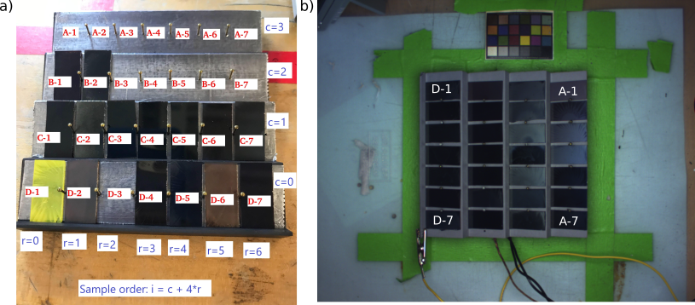

Figure X: Sample indexing viewed a) from the front of the chamber and b) in the resulting pictures. Sample index in the analysis codes is i, calculated based on the equations shown. To facilitate comprehending the sample location in the chamber and to avoid mistakes in sample indexing, a letter-based naming system is also used in the resulting tables. It names the columns of the sample holder from A to D, and positions from 1 to 7 as illustrated.

Light intensity calibration result

Figure XI: Exemplary light intensity calibration result of MIT Gen. 1 chamber. Intensities shown as Suns experienced by MAPbI3 samples.

Spatial temperature uniformity of the sample holder

Figure XII: Uniformity of the temperature across the sample holder in MIT Gen 1 chamber.

Longitudinal stability of the humidity and temperature within the chamber

Figure XIII: Longitudinal stability of air humidity and temperature in MIT Gen 1 aging chamber during a 23.5-hour aging test. Relative air humidity (%rh) shown with blue color, temperature (°C) shown with red color, and dew point (%rh) shown with green color. Direct output graph from the humidity tracker software shown.